软件设计与体系结构小测验（开卷）
（2017~2018学年第2学期No.3）
学号： 姓名：
1．Analyze the following structure, and answer the following questions.
1) Which structure does the following graph represent? (25)
2) Explain the structure, include: role(25), element, relation of the structure(25), and relative quality attributes(25)
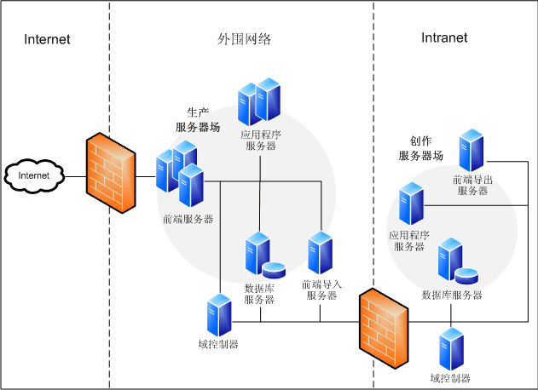
This is deployment structure(25); deployment structure shows how software is assigned to hardware(15).
Element: Components, hardware element(10)
Relation: Allocated to, migrates to(15)
Useful for: Performance, availability, security analysis(10)
Quality Attributes affected: Performance, security, availability(25)

